Article Authors: Bausch, Nils; Dawkins, David P.; Frei, Regina; Klein, Susanne

Article Title: 3D Printing onto Unknown Uneven Surfaces

Purpose of the study: New methodology combining 3D Scanning, multiple axis 3D printing, and conformal printing

Research Questions: Print on unique objects, using low-cost system for conformal printing

Current Knowledge on Topic/Introduction: The area is dubbed “conformal printing.” Current 3D printers which are able to do this are expensive and sophisticated. They are mostly used for “printing electronic circuits and similar applications.” The authors claim that these systems require an “electronic model of the object to be printed on,” allowing the pathing of the printer to be determined in advance.

Authors combine 3D scanning, data processing, and Fused Deposition Modelling (FDM).

Freeform Manufacturing - capability of creating shapes not in typical geometrical form, while still maintaining control.

Challenges: (1) identify the surface as a *point cloud* (2) generate tool path on point cloud data

3D Scanning can range from “single-point to sophisticated line laser accompanied by detector or camera module… to convert data into 3D surface definitions”

(as of Jan 1, 2016: no solution for conformal printing onto uneven surfaces at any scale)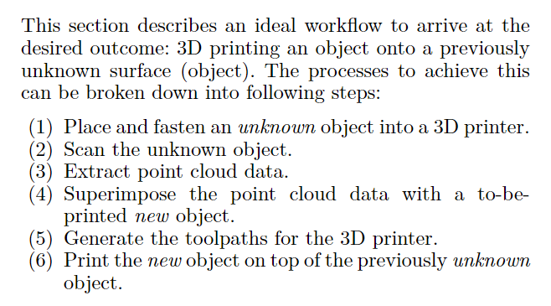

Results/Future Work: Only the first layer was able to be printed through their prototype.

Authors say that the technology could be used for “repairing structures, product customization, printing security features on existing objects, adding functionality by, for example, printing antennas on items, and modifying prosthetics to fit individual patients.”

Relation to Project: this is our project

Sources (Is there more info in *its* sources?): (Definitely; any articles related to this one would be applicable) [TODO]

Additional Notes:

Journal to look into: *3D Printing and Additive Manufacturing*

Made In Space - a company who is researching in-orbit manufacturing. They also have an extreme environment 3D printing equipment section.